“Early Settlers Burial Ground /
First Town Cemetery”
Greenland, New Hampshire

By Tom Ayres
June 15, 2018

Weeks Public Library “A CHRONOLOGY OF GREENLAND HISTORY Compiled by Paul Hughes”. “1671 North Church founded (S. Haines, Deacon), land set aside for 1st cemetery on Winnicut River.”

M. O. Hall, 1900. “Rambles About Greenland in Rhyme” (page 83). “There is a hiwaye laid out over against Leonard Weeks house and is toe go over his land soue [south] by west or therabouts until it comes to common land. … and it is on this land that the first burying place was made – and back in the woods near the river there were laid more than one hundred of the early dead.”

“New Hampshire Old Graveyard Association” (NHOGA) burial sites in Greenland, New Hampshire (www.nhoga.com/sites/oga_G10.htm). Paul Hughes Sr., 1988 MAP. G10-033 First Town Cemetery, near Winnicut River, USGS Portsmouth Quadrangle, E34959, N476648, Zone 19 (43° 2' 17"N, 70° 50' 47"W), Master Map 243.

Paul Hughes, Jr., 2001. Greenland’s first burying ground, was set aside in 1671.

Neill DePaoli, Ph. D. (Historical Archaeologist), issued “Three and A Half Centuries in Greenland, New Hampshire: The Weeks Brick House Farm of New Hampshire”, (page 12) in September, 2003. Greenland’s first “burying ground” was roughly 600 yards west of Greenland’s town landing. In 1671, the town of Portsmouth set aside an acre of land for Greenland’s first “burying ground”. The tract abutted the western boundary of Leonard Weeks property. Today the burial ground is set on a moderately wooded knoll overlooking the Winnicut River, roughly (1,000 feet) north of the Restaurant on Route 33. It is here that Leonard and his second wife Elizabeth are probably buried.

Dr. DePaoli, in 2007, conducted an archaeological dig at the Weeks Brick House, including the use of ground penetrating radar. It also confirmed the location of the burial ground of Greenland earliest settlers --- on a point just across the Weeks Farmstead rear property line in the woods overlooking the Winnicut River. The ground penetrating radar confirmed the possibility of graves, and the area was marked with small 2”x2” flags. There are no gravestones standing, however there are a few stones scattered in the area that may have marked graves.

Rev. Frank Weeks, author of the “Descendants of Leonard Weeks, 1636-2016” received information that Samuel and Eleanor Haines Weeks were buried in the Early Settlers Burial Ground.

Weeks Brick House Map
2008
By R. W. Bacon

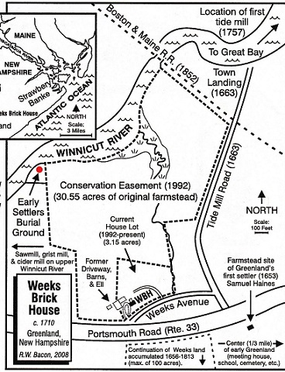

Early Settlers Burial Ground Photos
By Tom Ayres
May 21, 2018

There are no gravestones.
